Day in the Life of the Hudson River 10/13/22
Pier I, NYC
RIVER MILE: 6.8
Salt Front: ~ RM 76
Speyer Legacy School (7th grade)– Kimberely Schwab
36 students & 4adults
Latitude 40.7099° N & Longitude – 73.9845°W
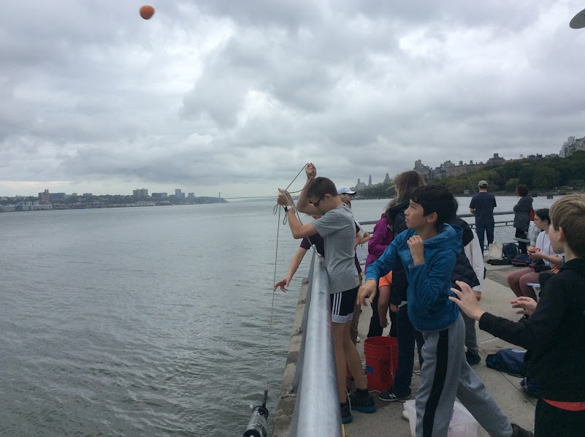
Location: Pier I, NYC
Area: Pier was built on a dormer railroad pier jutting out at an angle from Riverside Park South.
Surrounding Land Use: Urban/Residential
Sampling Site: Pier
Shoreline: Sandy, rocky
Water: Choppy
Plants in area: No plants in the water
*NR = Not read/recorded
ITEM |  | Time |  | Reading |  |  |  | Comments
Physical
Air Temperature- |  | 10:00 AM  10:30 AM  11:00 AM |  | 19.44°C  20°C  20°C |  |  | 67°F  68°F  68°F
Wind Speed: |  | 10:00 AM |  | Anemometer  NR |  |  | Beaufort  2 | Direction  NR
Weather today |  | 11:00 AM |  | >75% cloud cover |  |  | Intermittent light rain
Weather the past 3 days: |  | Sunny, beautiful, rainless
Tides- NR |  | Time |  | Rising, Falling, Unchanged |  |  | Water Height (cm)
Current- |  | Time |  | Cm/sec |  | Knots | North/South | Ebb/Flood/Still
 |  | 10:00 AM  10:30 AM  11:00 AM  11:30 AM |  | 37.6  58  69.5  26.9 |  | 0.73  1.12  1.35  0.52 | NR | Flood  Flood  Flood  Flood
Water Temperature- |  | 10:00 AM  10:15 AM  10:30 AM |  | 17°C  19°C  18°C
Turbidity- Long Sight Tube (120 cm) |  | 10:00 AM  10:30 AM  11:00 AM |  | 53.6 cm  30.26 cm  34.1 cm
Chemical
Salinity-Hydrometer |  | 10:00 AM  10:30 AM  11:00 AM |  | 22 ppt  18 ppt  21 ppt
Standardized Salinity –
DO – Hach Drop Kit |  | Time  10:00 AM  10:30 AM  11:00 AM |  | Temp  NR |  |  | ppm DO  9 ppm  6 ppm  7 ppm | % saturation  NR
pH – |  | 10:00 AM  10:30 AM  11:00 AM |  | 7.5  7.5  7.5
Nitrates- NR
Phosphates- NR
Alkalinity- NR
Biological-
Fish – Fish Traps |  | Number |  | Name |  |  | Length of longest | Length of smallest
 |  | 3 |  | Cunner |  |  | 9 cm | 7.6 cm
Fish Totals |  | TOTAL: 3 |  | Diversity: 1
Macroinvertebrates |  | Number |  | Name |  |  | Length of longest | Length of smallest
 |  | 9 (3F, 6M) |  | Blue Crab |  |  | 14 cm | 12.7 cm
Macroinvertebrate Totals |  | TOTAL: 9 |  | Diversity: 1
Sediment Core - NA
Length | H2S smell |  | Oxid Top |  | Oil |  | Grain Size | Other Features
Boats-NR
 | Time |  | Name |  | Color |  | North/Southbound | Light/Loaded

